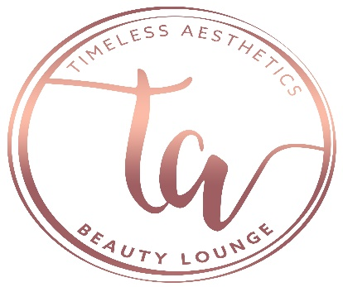
Client Consent Form: Brow/Lash Tint and Lash Lift
Date:_______________________________
Name:__________________________________________ Date of Birth:____________________
Address:_____________________________________ City:___________ State:____ Zip:____________
Home Phone:______________________ Business Phone:_____________________
Cell Phone:________________________ Cell Provider:___________________
E-mail address:___________________________________________________Single: No Yes Married: No Yes, if yes, anniversary date:________________
Employer:_____________________________ Occupation:_____________________________ Does your job require that you work outdoors? No Yes
Referred by:_______________________________________________________________________
Have you ever used hair color before? No Yes
Have you ever had an allergic reaction to hair color? No Yes
What over-the-counter or prescription skin care products are you currently using?_____________________________________________________________________________________________________________________________________________________Do you have diabetes, lupus, or any auto-immune disease? No Yes (if yes, describe)_______________________________________________________________________________________________________________________________________________________________
Please list any illnesses or conditions you are being treated by a physician for:_____________________________________________________________________________________________________________________________________________________________________
Please list any medications you are taking, including over-the-counter herbs, vitamins, and supplements:_____________________________________________________________________________________________________________________________________________________________
List any allergies you have:___________________________________________________________
Have you ever had your brows tinted? No Yes
If you had an adverse reaction to a previous tinting, please explain:__________________________________________________________________________________________________________________________________________________________________
Although every precaution will be made to ensure your safety and well-being before, during and after your tinting application, please be aware of the possible risks below. Please initial:
_______ I understand that tinting brows/lashes or lash lifting has some inherent risk or irritation to the orbital eye area, including the eye itself, and could result in stinging or burning, blurry vision, and potentially blindness should the tint enter into the eye.
_______ l understand that if the tinting/lifting agent developer or mixture of both accidentally comes into contact with my eye, my eye will be flushed with water and medical attention may be required.
______ l understand that some irritation, itching or burning may occur to the skin which comes in contact with the tinting/lifting agent.
______ I understand that there may be some residual dark staining left on the skin following the tint process of either my lashes, brows, or both. This will fade and go away within a short time.
______ l understand that, while every attempt will be made to provide me with my chosen color everyone’s hair absorbs color differently and my final results may not be the color I initially wanted.
_______ l understand that over the course of several weeks, the tint will gradually lighten, fade, and/or the lash curl will relax. Re-tinting will be required to keep the new color fresh. Most clients need to re-tint every 3-4 weeks. Re-lifting will be required to keep the curl and lift fresh. Most clients need to re-lift every 6-8 weeks.
I have read the above information. If I have any concerns, I will address these with my skin care therapist. I give permission to my therapist to perform the tinting procedure we have discussed and will hold him/her and his/her staff harmless from liability that may result from this treatment. I have accurately answered the questions above, including all known allergies, prescription drugs, or products I am currently ingesting or using topically. I understand my esthetician will take every precaution to minimize or eliminate negative reactions as much as possible. In the event I may have additional questions or concerns regarding my treatment, I will consult the esthetician immediately. I agree that this constitutes full disclosure, and that it supersedes any previous verbal or written disclosures. I certify that I have read, and fully understand, the above paragraphs and that I have had sufficient opportunity for discussion to have any questions answered. I understand the procedure and accept the risks. I do not hold the esthetician, whose signature appears below, responsible for any of my conditions that were present, but not disclosed at the time of this skin care procedure, which may be affected by the treatment performed today.
Client Name (printed):__________________________________________ Date:_______________
Client Signature:________________________________________________ Date:_______________
Esthetician Signature:___________________________________________ Date:_______________

